Adrianus Indraprasta Dwicaksana

Kelas Flutter B

### **Tugas bloc(Eksplorasi)**

1. Bukalah tugas([12. Soal Assets, Dialog Bottomsheet, Navigation](https://www.notion.so/12-Soal-Assets-Dialog-Bottomsheet-Navigation-b0ce043cec734de0adb835ee185c9850) )
2. Tambahkan & Implementasikan penggunaan state management BLoc pada aplikasi tesebut.

Contact_bloc.dart

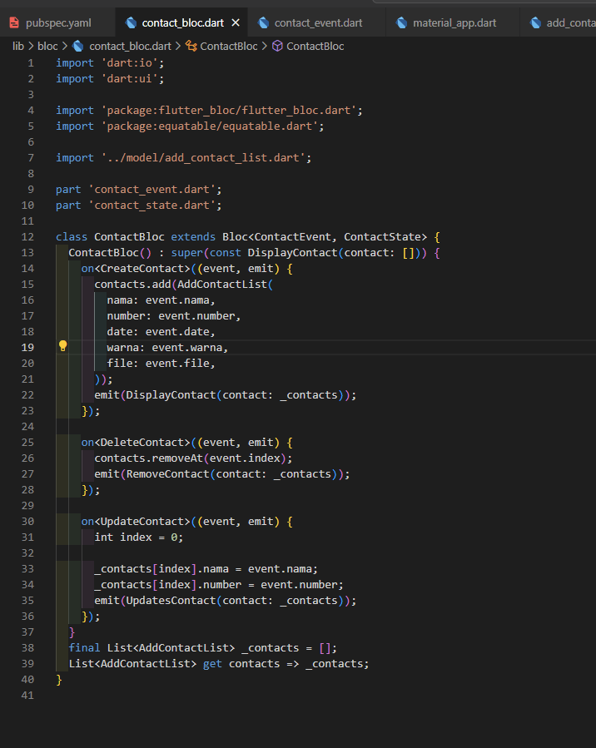

Contact_event.dart

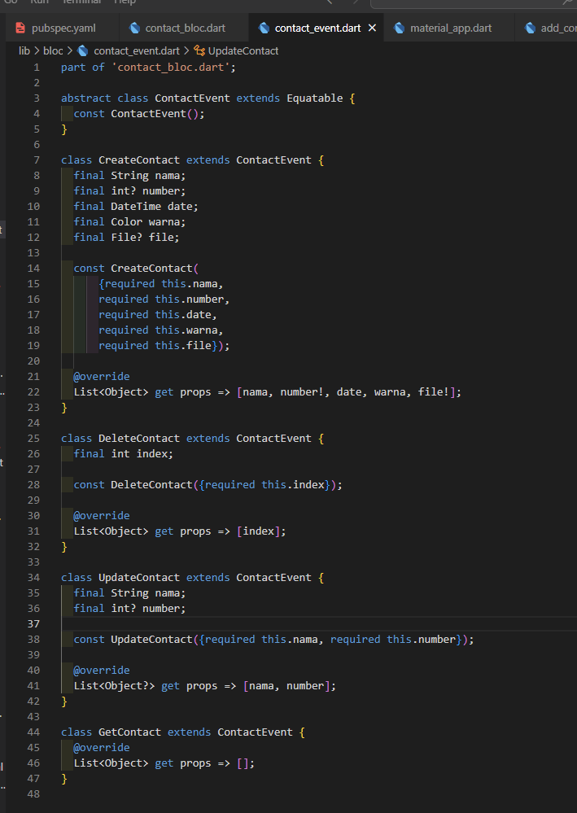

Contact_state.dart

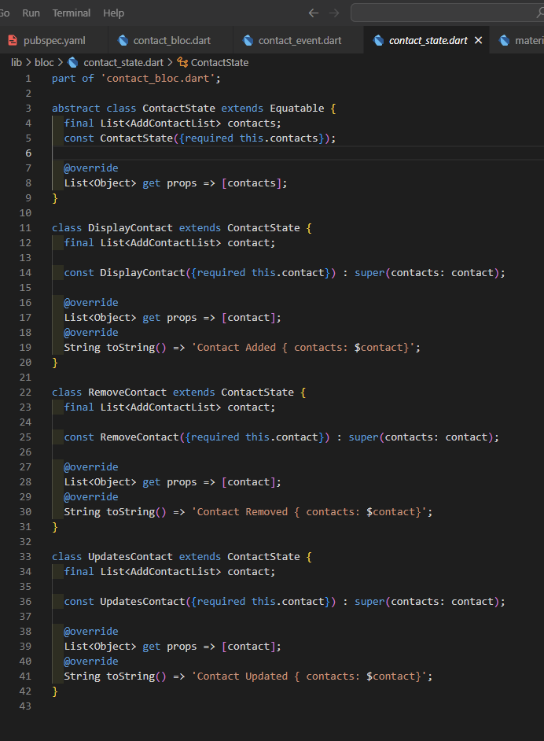

BlocProvider (MaterialApp)

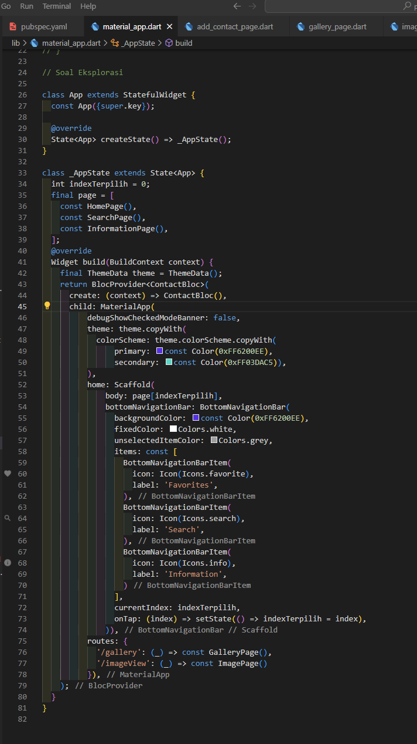

BlocBuilder

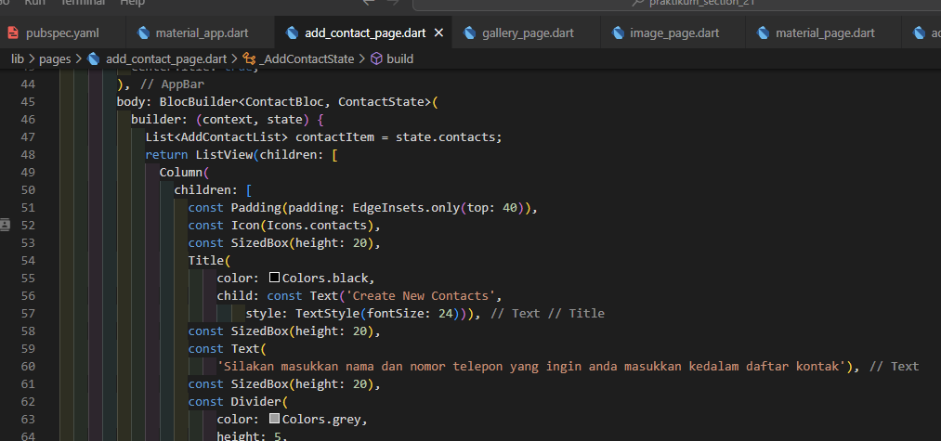

CreateContact/AddContact

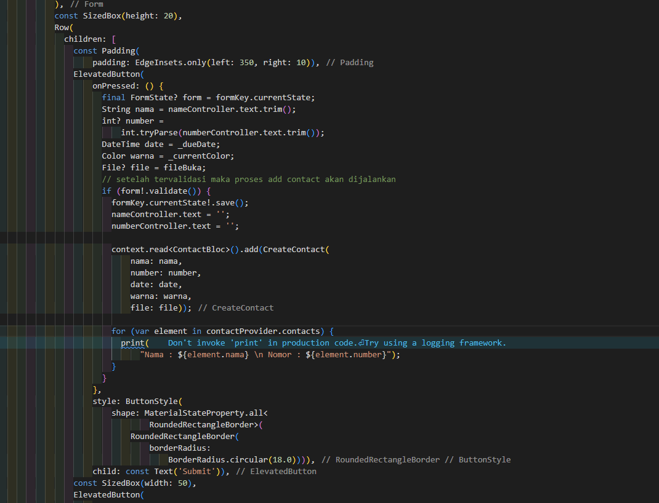

Update/Edit Contact

